

----------------------------

**Jury Number : ----------**



**TOPIC TITLE**

**Thesis for the award of the Bachelor of Science in Computer Science**

Presented and publicly defended on [--/07/2021] by

**BOUKARY kABORE**

Supervised by: **Mr. Ousmane DRABO**

Teacher at BIT

Jury :

President : ----,-------

Members : 1) ---, ----,------

2) ----, ------

**Promotion [2018/2021]**



TOPIC: Hardware store products online selling web application development

It’s with pride and enthusiasm that I dedicate this thesis to my dearest honorable and lovely parents, brothers and sisters who have fought day and night and continue to fight for my well-being with their financial and moral supports, prayers and advice.

# **DEDICATION**

My tanks go to the place:

To all the members of KABORE family and all acquaintances, who from far or near have participated differently in the success of this work;

To Mrs. SUSANNE PERL, the founder of BIT, who offered us the opportunity to follow an international training in English from our home (Burkina Faso);

To the members of Jury for the analysis and the study of my thesis. Also for the suggestions they will address me;

To Mr. Ousmane DRABO, our thesis master for his guidance and assistance;

To the entire BIT team for their advice, availability, guidance, and sharing of knowledge and experience during our stay at BIT;

To all those who have participated in one way or another in the good running of the work;

.

# **ACKNOWLEDGEMENTS**

# **Abstract**

The e-commerce includes all techniques, strategies and tools used for trade on internet. It general objective is to bring more visibility to companies and also to optimize the sale of their services.

In order to be more useful to our society we think to put our knowledge to the profit of hardware stores and mini hardware stores of Burkina Faso by supporting them in their trade through a solution. This project aims to achieve a web e-commerce solution adapted to the sale and promotion of their services.

What solution to implement to improve the sale of hardware store products and promote their visibility on the one hand and make easy the accessibility of their product to their customers on the other hand?

In order to answer this problematic, a questionnaire was established and addressed to 20 hardware stores managers in Koudougou. we opted for this methodology because it allows us to collect quantitative data with an audience or public at a lower cost and does not put pressure on the target audience.

Based on the responses collected, we conclude that most hardware stores and mini hardware stores limit their sales environment and their clientele because of the lack of integration of trading tools in their business.

1. Increase the profitability of hardware managers
2. Hardware product
3. Web e-commerce solution
4. Hardware and mini hardware store
5. Sales, visibility and advertising

# **Summary**

Le e-commerce regroupe l’ensemble des techniques, stratégies et outils utilisés pour le commerce sur internet. Il a pour objectif général d’apporter plus de visibilités aux entreprises et aussi d’optimiser la vente de leurs services.

Afin d’être plus utile à notre société nous pensons mettre à profit nos connaissances aux quincailleries et mini quincailleries du Burkina Faso en leur soutenant dans leur commerce à travers une solution appropriée, laquelle solution a pour objectif de réaliser une application web de e-commerce adaptée à la vente et à la promotion de leurs services. Alors quelle solution implémentée pour améliorer la vente des produits de quincailleries et prôner leur visibilité d’une part et faciliter l’accessibilité de leur produit à leurs clients d’autre part ?

Afin de répondre à la dite problématique un questionnaire a été établi et adressé à 20 responsables de quincaillerie de Koudougou. Nous optons cette méthodologie parce qu’elle permet de collecter des données quantitatives avec un public à un coût moins élevé et ne met pas de pression sur le publique cible.

D’après les réponses recueillies nous concluons que la plupart des quincailleries et mini quincailleries limitent leur environnement de vente et leur clientèle à cause de la non intégration des outils de commerce dans leur commerce.

Mots Clés :

1. Augmenter la rentabilité des responsables de quincaillerie
2. Produit de quincaillerie
3. Solution web de e-commerce
4. Quincaillerie et mini quincaillerie
5. Vente, visibilité et publicité

TABLE OF CONTENTS

**DEDICATION** i

i

**ACKNOWLEDGEMENTS** ii

**Abstract** iii

**Summary** iv

**List of Acronyms AND Abbreviations** 1

**LIST OF FIGURES** 2

**LIST OF TABLE** 3

**General introduction** 4

**PART I : THEORETICAL STUDY** 6

**Chapter 1: Generality on the topic** 7

**I.** **Concepts’ definition** 7

**II.** **Context and Problematic** 7

**III.** **Objectives** 8

**IV.** **Hypothesis** 8

**V.** **Methodology** 9

**VI.** **Expected results** 9

**Chapter 2: Methodology of study** 10

**I.** **UML and Merise presentation** 10

**1.** **UML presentation** 10

**2.** **Merise presentation** 11

**3.** **Justification of the choice of modeling language** 11

**PART II : PRACTICAL PART** 12

**Chapter 1: Application conception** 13

**I.** **Needs’ specification** 13

**1.** **Functional needs specification** 13

**2.** **Technical needs specification** 14

**II.** **User case diagram** 15

**III.** **Sequence diagram** 16

**IV.** **Class diagram** 19

**V.** **Deployment diagram** 20

**Chapter 2: Achievement and results** 21

**I.** **Presentation of results** 21

**1.** **Presentation of the survey** 21

**2.** **Results of questions** 21

**3.** **Results analysis** 22

**II.** **Codes and interfaces** 22

**III.** **Security and extension Strategy** 29

**1.** **Security strategy** 29

**2.** **Extension strategy** 29

**Conclusion and perspective** 31

**Bibliography and bewbography** 32

**APPENDICES** 33

**Summary of appendices** 33

# **List of Acronyms AND Abbreviations**

**Ajax:** Asynchronous JavaScript and XML

**BIT:** Burkina Institute of Technology

**CSS:** Cascading Style Sheets

**HTML:** HyperText Markup Language

**MCD:** Conceptual Data Model

**MLD:** Logical Data Model

**MPD:** Physical Data Model

**PHP:** Hypertext preprocessor

**DBMS:** Database Management System

**SQL:** Structured Query Language

# **LIST OF FIGURES**

Figure 1 : Use case diagram of users of the system 15

Figure 2 :Visitor sequence diagram 16

Figure 3 : Customer sequence diagram 17

Figure 4 : Admin sequence diagram 18

Figure 5 : Class diagram 19

Figure 6 : Deployment diagram 20

Figure 7 : Front code of login form 23

Figure 8:Login interface 24

Figure 9: Back code for user account creation 25

Figure 10: User account creation interface 26

Figure 11 : Product overview code and interface 27

Figure 12 : Back code of the product gestation table 28

Figure 13 : Product management interface 29

# **LIST OF TABLE**

Table 1:Comparative table of UML and Merise 11

# **General introduction**

Nowadays, digital technology with its multiple advantages has strongly impacted the world. In fact, many enterprises or companies have more and more recourse to IT in order to take full advantage of the digitization of services.

E-commerce is nowadays indispensable. According to studies (confers source [1]) 95% of purchases will be made online by 2040. Indeed, statistics of electronic commerce or e-commerce demonstrate the success of online sales progress. For example, in 2017, internet sales generated $ 2.3 billion and this value increase year after year (confers source [1]). Despite these many advantages, many hardware and mini hardware stores in Burkina Faso are still in the traditional (physical) trade. As a result, they are limited on the one hand by the fact that they are absent on the web or in the digital market. This does not favor the presentation of their services 24 hours a day in order to reach more customers and expand their market. On the other hand, they do not have a system for selling and advertising their products online. This does not promote their visibility and the accessibility of their products to their customers through the web. Some of them use social networks to sell their products. However, the use of social networks like Facebook, LinkedIn, twitter, Instagram only for their business does not guarantee better visibility and sale of their services. Also they do not promote the follow-up of their customers in order to optimize the sale of their product. As a result, social networks and e-commerce web applications are complementary. Some of them use social networks to sell their products. However, the use of social networks like Facebook, LinkedIn, twitter, Instagram only for their business does not guarantee better visibility and sale of their services. Also they do not promote the follow-up of their customers in order to optimize the sale of their product. As a result, social networks and e-commerce web applications are complementary. Some of them use social networks to sell their products. However, the use of social networks like Facebook, LinkedIn, twitter, Instagram only for their business does not guarantee better visibility and sale of their services. Also they do not promote the follow-up of their customers in order to optimize the sale of their product. Therefore, social networks and e-commerce web applications are complementary.

In order to find an adequate solution so that the hardware stores and mini hardware stores of Burkina Faso can take full advantage of e-commerce, we took as a theme for the end of the cycle for obtaining the degree in computer science: <<Hardware stores products online selling web application development >>.

To carry out our work we are going to focus the redaction of our thesis on two main parts.

In the first part entitled theoretical study, we approach the presentation of our theme on the one hand and present the methodology of our study on the other hand.

Then in the second part called practical study we discuss the conception of our application as well as the achievement and results of said application.

# **PART I : THEORETICAL STUDY**

# **Chapter 1: Generality on the topic**

In this chapter we will describe the context, the problematic, the hypothesis, the objectives, the methodology and the expected results.

## **Concepts’ definition**

**web application**: A web application is an application generally installed on a server and users through a web browser and via a computer network interact directly online with

**Hardware product**: Set of equipment sold in a hardware store they are among others construction materials (reinforcing bar, tiles and cements), welding materials (soldering irons), electrical materials and various.

**Hardware store**: Trade of metal objects of all kinds.

## **Context and Problematic**

The classic sales system, as practiced by many traders, in specially sellers of hardware and mini hardware products, is as follows.

The customer inquiries about the price of the equipment he wishes to buy. Once this information has been acquired, he goes to order. After passing the order, he pays and obtains a purchase invoice. It is with this invoice that he will have its goods delivered. It is the responsibility of the manager and employees of the hardware and mini hardware stores to ensure the availability of materials that are most in demand, to have an idea of ​​the stock of products and to make the various deliveries. As a result, there is often a great risk of stock shortage. Hardware stores or mini hardware stores are often restricted to their customers. To extend the market, and boost sales, it is imperative to digitize the offers or services through the advantages of the web.

The web has many advantages for the marketing of products and allows to integrate a larger market. As an example of sales platforms we have Alibaba, Amazons. However, in Burkina Faso many companies do not take profit of these advantages, in particular hardware stores and mini hardware stores in Burkina Faso.

For this we will reflect on the following questions:

How can we help hardware stores and mini hardware stores in Burkina Faso to benefit from the advantages of e-commerce?

How can we increase the visibility of hardware stores and mini hardware stores in Burkina Faso in order to facilitate the expansion of their market?

What tools can we make available to them to facilitate the sale of their products and the accessibility of their products to their customers?

## **Objectives**

The main objective of this Project is to design a secure web application adapted to the needs of hardware stores and mini-hardware stores in Burkina Faso.

In order to achieve our general goal. We will:

First, sensitize responsible of hardware and mini hardware stores in Burkina Faso on the importance of e-commerce.

Then listen to them in order to better understand their needs.

Finally, develop the e-commerce web application meeting the needs expressed by users (customers and hardware store).

## **Hypothesis**

The problems of visibility and non-use of e-commerce sites can be explained by several hypotheses.

Hypothesis 1: The e-commerce applications available on the market are not suited to the needs of hardware and mini hardware stores and their acquisition cost is high.

Hypothesis 2: Many hardware stores and mini hardware stores are unfamiliar with e-commerce.

Hypothesis 3: They do not know e-commerce applications, therefore they do not know the advantage of using them.

## **Methodology**

To carry out our study, we submitted a questionnaire to managers of hardware and mini hardware in the city of Koudougou. Its aim was to identify the reasons for their absence on the web on the one hand and on the other hand to collect their opinions or needs in order to promote their integration on the web. During this survey we interviewed 20 managers of hardware and mini hardware in city of Koudougou.

## **Expected results**

As an expected result at the end of the project, our application will allow hardware and mini-hardware stores:

* To be more visible through the advertising of their products on the web,
* To make online sales,
* To expand their market,
* To facilitate the accessibility of their products to their customers. This will allow customers to easily order and pay for hardware products without having to travel.
* To reach more customers all over the world, more precisely in Burkina Faso,
* To be 24 hours a day open to their customers.

This chapter has allowed us to better understand our theme. In fact, it allowed us to approach the context, the problematic, the objects, the methodology and the expected results. The following chapter presents the methodology of the study.

# **Chapter 2: Methodology of study**

This chapter will be the subject of the presentation of analysis methods such as UML and Merise as well as the development process.

## **UML and Merise presentation**

### **UML presentation**

Modeling, which is an engineering technique used in order to better understand the functioning of a system, to control its complexity and to ensure its coherence. Therefore, it is necessary and capital to model a system before realizing it.

UML (Unified Modeling Language) is a graphic language that helps to represent and communicate the different aspects of an information system, it is based on object oriented concepts. UML is universal language because it is flexible, versatile and its implementation is independent of programming languages, application domains and processes.

UML has implemented the notion of diagram-based view to facilitate a complete view of the system in fractional time. Therefore, UML2.0 offers thirteen (13) diagrams structured in three (3) models.

First we have the static model: It constitutes by diagrams of classes, objects, components, deployments, packages and composite structures. It is used to represent the system physically.

Second we have the dynamic model: composed by diagrams of activities, use cases and states-transitions. It shows how the system works.

To finish we have the interaction model: As its name suggests represent the different interactions between the actors of the system and the system. Also it represents the different communications between the objects of the system. In this model we can find, diagrams of communication or collaboration, sequence, global interaction and time.

### **Merise presentation**

Merise is a method of analysis and realization that starts from the conceptual data model (CDM) to the logical data model (LDM) and from the logical data model to the physical data model (PDM), then the database.

### **Justification of the choice of modeling language**

Table 1:Comparative table of UML and Merise

|  |  |
| --- | --- |
| **UML** | **Merise** |
| UML is object oriented | Merise is relational oriented |
| Generates a visual model. It is therefore more realistic | Processes and designs relational database models. So it is more theoretical |
| Models the system with sequence, class, activity, use case diagrams and more | Proposes rules to switch from MCD to MLD then from MLD to MPD and then from MPD to database |
| Represents the information system | Analyzes and designs the information system |

Several reasons justify our choice to use UML as the modeling language.

First of all, the universality of UML allows us to model the different aspects of our solution independently of programming languages, application domain and development processes.

Then UML through these models (static, dynamic and interaction) allows us to represent and communicate the different aspects of our information system. For this it is easy for us to have a complete view of our system in a short time in order to compare and evaluate it.

Finally, UML through its analysis approach allows us to better understand the functioning of our application through abstract representations, master its complexity and ensure its coherence. Moreover, it is a normative, formal, precise and stable based on oriented object and it is required to model web solution with oriented language such as PHP, JAVA and others.

During this chapter we had the opportunity to present UML and merise. Then we established a comparative study between them. We continue the work by approaching Part II dedicated for practice.

# **PART II : PRACTICAL PART**

# **Chapter 1: Application conception**

In this chapter we talk about the technical and functional needs of our solution. Following this we discuss the class, use case, sequence and deployment diagrams of the said solution.

## **Needs’ specification**

The project consists of setting up an e-commerce web application for hardware and mini-hardware stores in Burkina Faso in order to promote their visibility, sale and accessibility of their product to their customers. Within our application each hardware store or mini hardware store has an account and can publish and sell its products. Visitors and Customer also have accounts.

### **Functional needs specification**

The main users of the platform are: The owners or managers of hardware and mini hardware stores, customers of hardware and mini hardware stores, administrators and finally visitors.

In our application the administrator performed the following actions:

* Create and manage hardware and mini hardware accounts (addition, deletion or deactivation and modification), it can also manage products from hardware and mini hardware stores (addition, deletion and modification),
* Create and manage users (add, delete or deactivate and modify),
* Manage documentation, stutterers and information exchange on the application.

The owners or managers of hardware stores perform the following tasks:

* Manage products from hardware stores or mini hardware stores (addition, deletion and modification),
* Manage the advertising of their hardware store,
* Manage orders of its hardware store.

Visitors have the right to visit the application only and when they are interested in the offers of our application he creates an account. A visitor can become a customer or a hardware store manager.

Customers can consult the application and make purchases of materials using an electronic cart with the actions to add a product, remove a product, modify a product from the cart and establish a payment.

### **Technical needs specification**

We define the technical needs of our application as follows.

#### **Hardware architecture**

Our platform is a client-server application. For its deployment, we need an application server (GlassFish) for the application and a database server (MySQL Server). Also we need a network firewall to prevent network traffic and an application firewall to prevent attacks.

#### **Overview on some web programming language**

* HTML5 /: Easy to build web content and to link to other page. It has a simple syntax.
* CSS: Allows us to easily style the interfaces of our pages. Indeed it allows to manage the formatting and the appearance of our interfaces.
* JavaScript: It allows to create and update content dynamically on the one hand and on the other hand it allows to control multimedia content and animate images
* Ajax: It is a JavaScript framework. This language gives the possibility dynamize our interfaces and avoid pages to reloaded entirely each new request of a user. As a result, it designs reactive and fast interfaces in execution.
* PHP: It interacts with the database and gives the possibility of combining html or JavaScript scripts inside its script.

#### **Overview on some DMBS**

MySQL 8.0.21: It is an open source DBMS,fast, free and easy to use. It is secure and offers a number of wide and rich functionality.

We chose MySQL on the one hand because it is easy to use and handles big data. On the other hand, it is free and allows you to perform various operations on the MySQL database through PHP.

#### **Overview on software used**

* Sublime 3.2.2 uses to edit our code,
* Wampserver 3.2.3 served as a local server to run our PHP code. We chose this software because it supports MySQL and PHP unlike XAMP.
* Power MC, StartUML were used for the modeling of our system. Power MC was used to generate the MCD, MLD, MPD and database of our solution. StartUML for its part to generate the use case diagrams, class diagrams and sequence diagram.

## **User case diagram**

Our use case diagrams look like this.

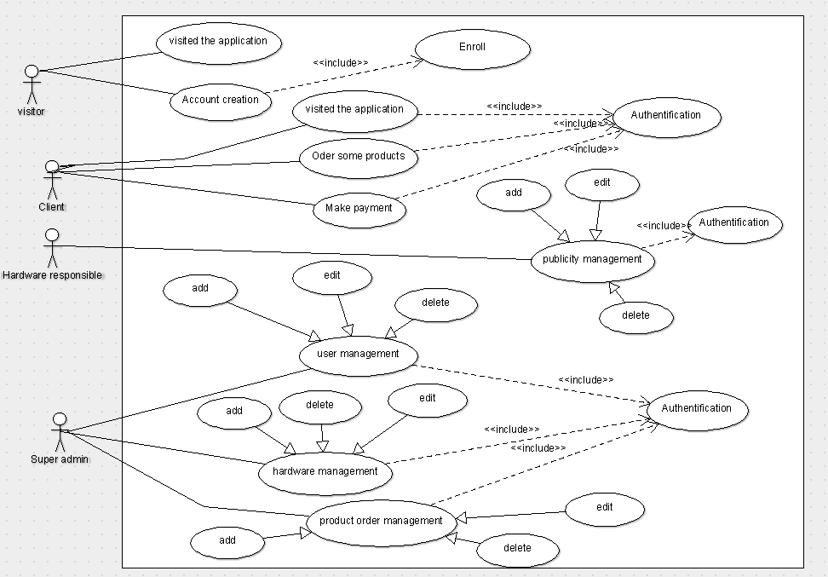

Figure 1 : Use case diagram of users of the system

## **Sequence diagram**

Regarding the sequence diagrams, we present that of visitors, clients and administrators. So they are presented as a continuation.

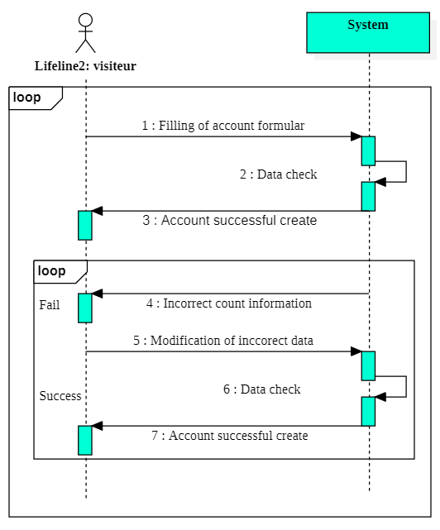

Figure 2 :Visitor sequence diagram

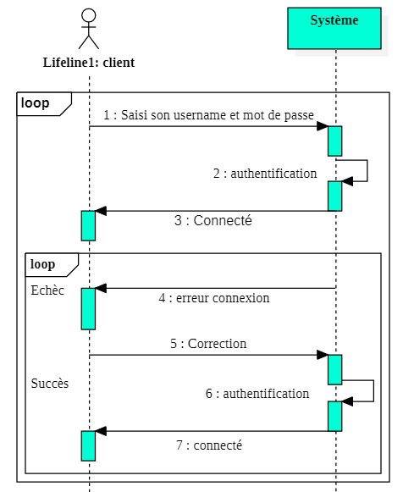

Figure 3 : Customer séquence diagram

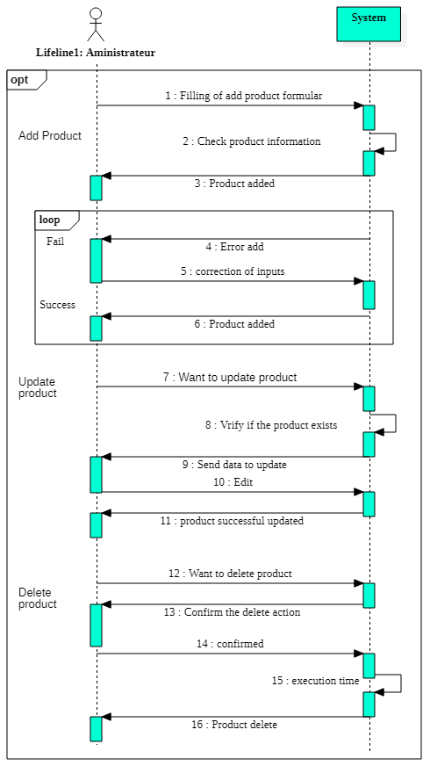

Figure 4 : Admin sequence diagram

## **Class diagram**

For this section we represent the diagram of our solution.

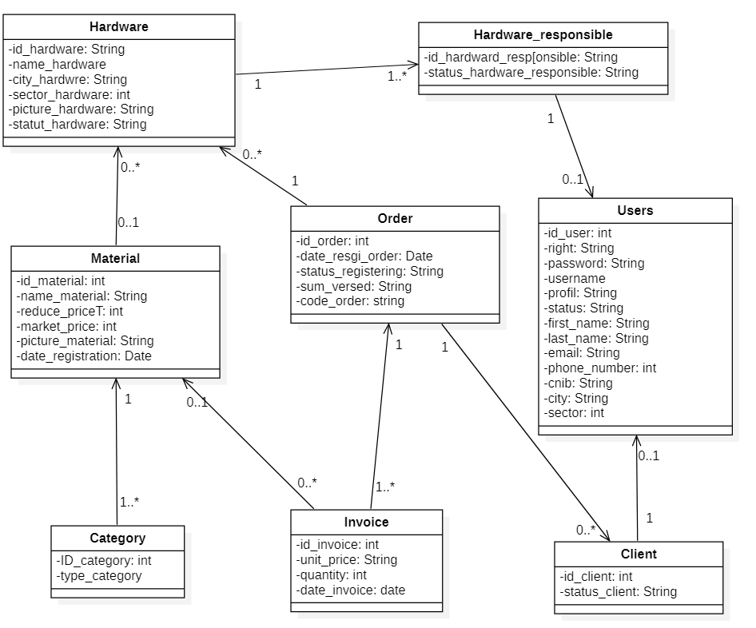

Figure 5 : Class diagram

## **Deployment diagram**

In this part we represent our application and the components used for its implementation and functioning. As described in chapter 1 in the hardware requirements specification part, we are using an application server, a database server and a router with a network and application firewall. So they are represented as a continuation.

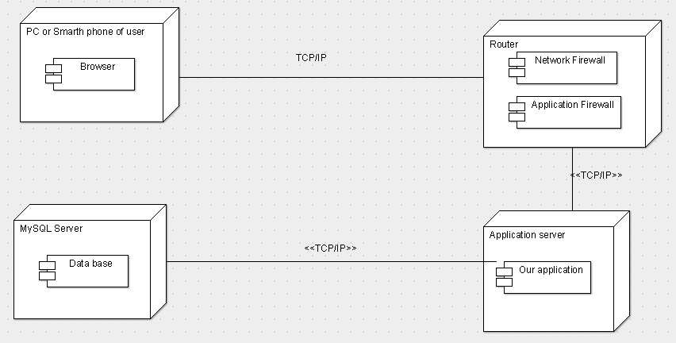

Figure 6 : Deployment diagram

In summary, the study of technical and functional needs allowed us to know the functionalities of our solution as well as the tools to use to implement it. Also the realization of the diagrams of classes, use cases, sequence and deployment gives us a glimpse on the future software. We move forward with Chapter 2 where we attack the realization and result phase.

# **Chapter 2: Achievement and results**

In this section we present our survey, then we present our questions and their results. In addition, we carry out an analysis of the results. Following this we present some codes and interfaces of our application and an overview of our security and innovation strategy.

## **Presentation of results**

### **Presentation of the survey**

Theme: << Web application design for the sale of hardware products >>.

In order to better trait our topic, we are effectuated a survey on the non-integration of e-commerce tools in the hardware and mini hardware stores of Burkina Faso. Its main objective was to better understand the reason for their absence on the web on the one hand and on the other hand to collect their opinions or needs in order to promote their integration on the web. As a research process, we first established a questionnaire and sent it to 20 managers of hardware and mini hardware stores in the city of Koudougou. After collecting their answers, we analyzed in order to locate the difficulties they are living.

### **Results of questions**

The results of our questionnaire are presented as follows (see annex 1 for the question form and annex 2 for the results of the survey):

* Do you have communication channels for the sale of your products?

Yes: 90%, No: 10%,

* If yes, which ones ? mouth to mouth and poster: 83%, Radio: 17%,
* Through these channels are you gaining more customers? yes: 78%, not so much: 17%, No: 6%,
* Have you thought about other communication channels? Yes: 33%, No: 67%
* If yes, which ones ? Facebook: 33%,
* Do you know the web applications? Yes: 25%, A little: 20, No: 55%,
* Do you have an e-commerce solution for the sale of your products? Yes: 20, No: 80,
* Do you think web applications are important? They are important: 20%, They are not very important: 20%, No ideas: 60%,
* What are the existing solutions in relation to your needs? Adapted: 20%, Unsuitable: 10%, No ideas: 70%,
* What is the state of the cost of acquiring existing solutions? Very expensive: 60%, expensive: 40%, less expensive: 0%,
* Do you need a solution to make it easier to sell and advertise your services or products? Yes: 70%, No: 30%,

### **Results analysis**

In view of the results obtained and the hypotheses declared in the first part of chapter 1, we confirm that:

Many hardware and mini hardware stores (80%) do not use e-commerce applications to sell their products.

This is primarily due to the fact that many (55%) hardware and mini hardware stores do not know web applications, so they (60%) do not know the importance of using these solutions. Then they (60%) testify (answer) that the acquisition of e-commerce solutions is very expensive.

Therefore, they use the following communication channels for the sale of their products: word of mouth and poster (83%), and Facebook (33%), Radio (17%).

## **Codes and interfaces**

In this part we present some interfaces and code overview of our application.

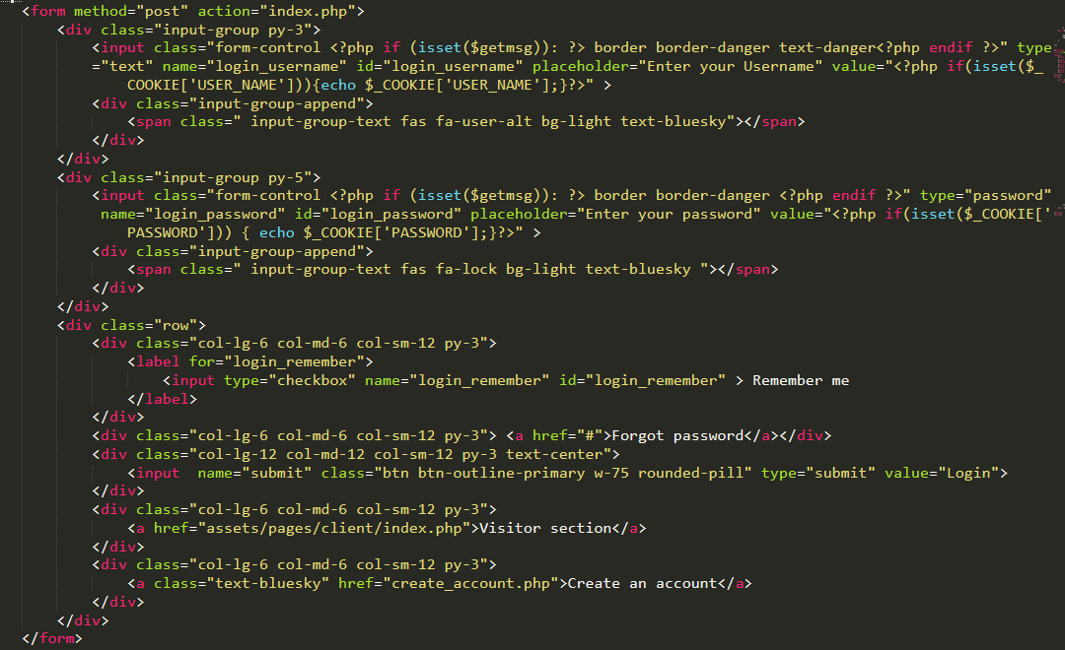

Figure 7 : Front code of login form

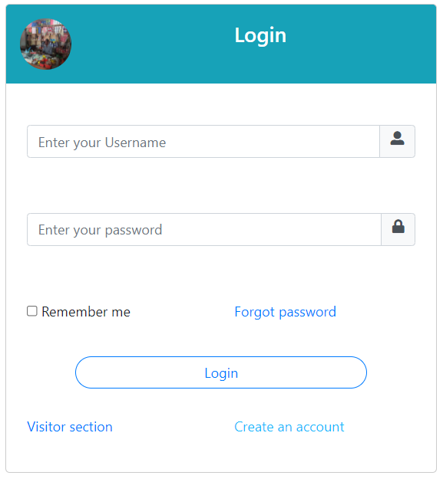

Figure 8:Login interface

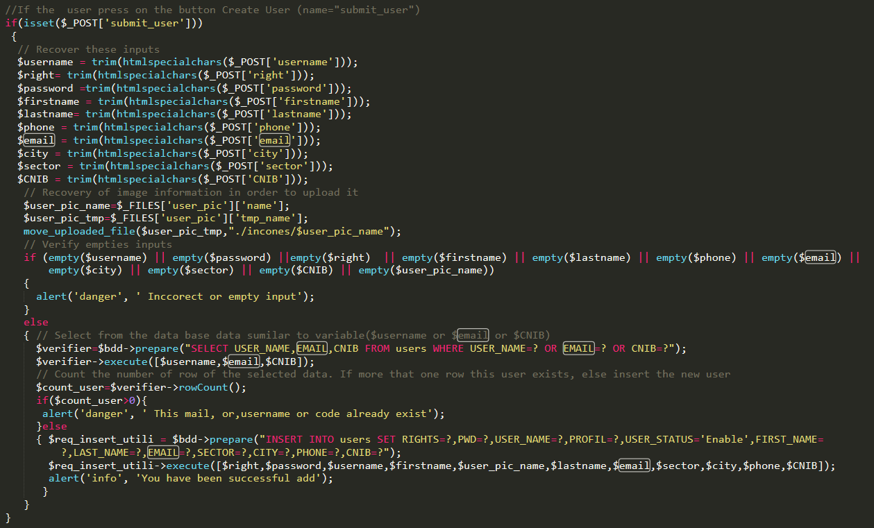

Figure 9: Back code for user account creation

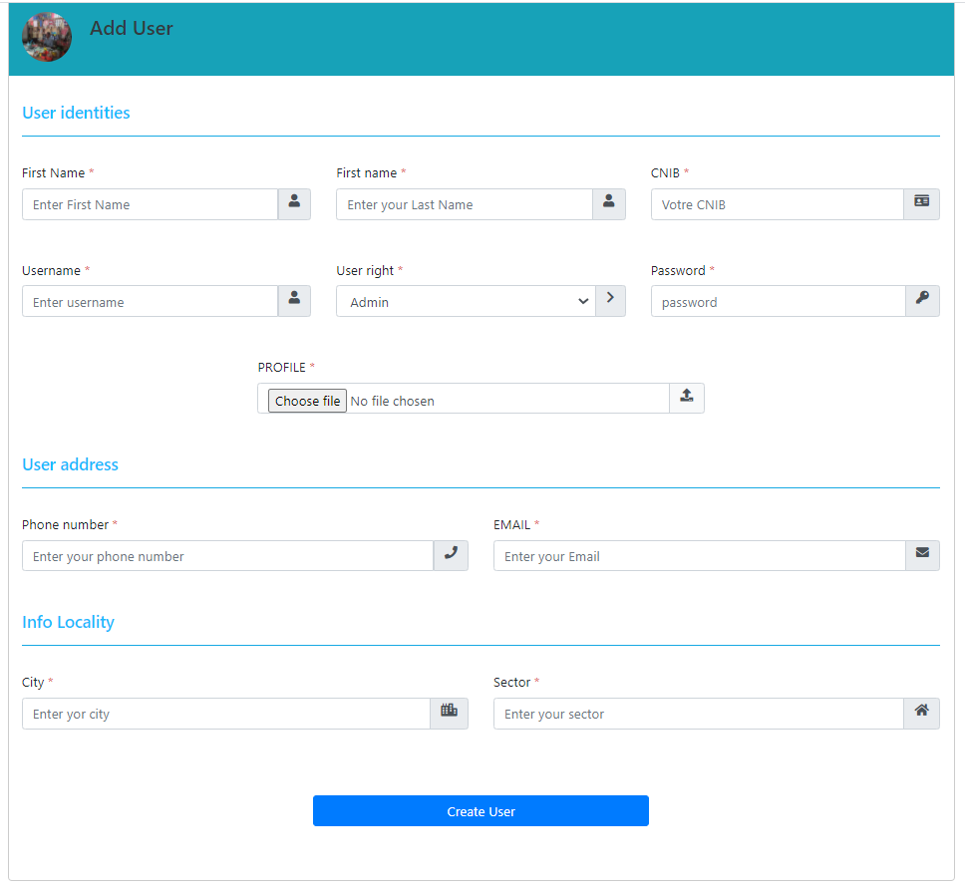

Figure 10: User account creation interface

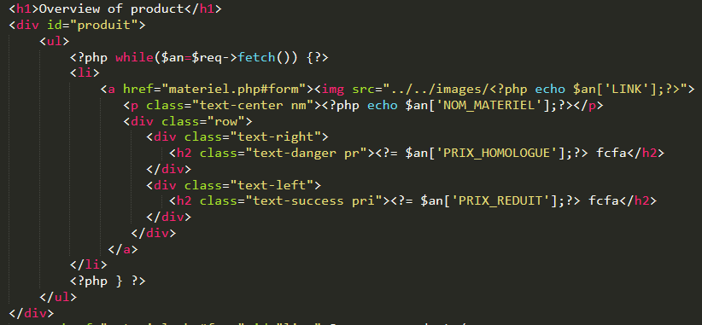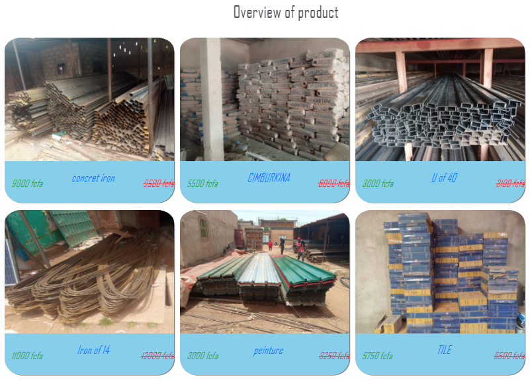

Figure 11 : Product overview code and interface

Figure 12 : Back code of the product gestation table

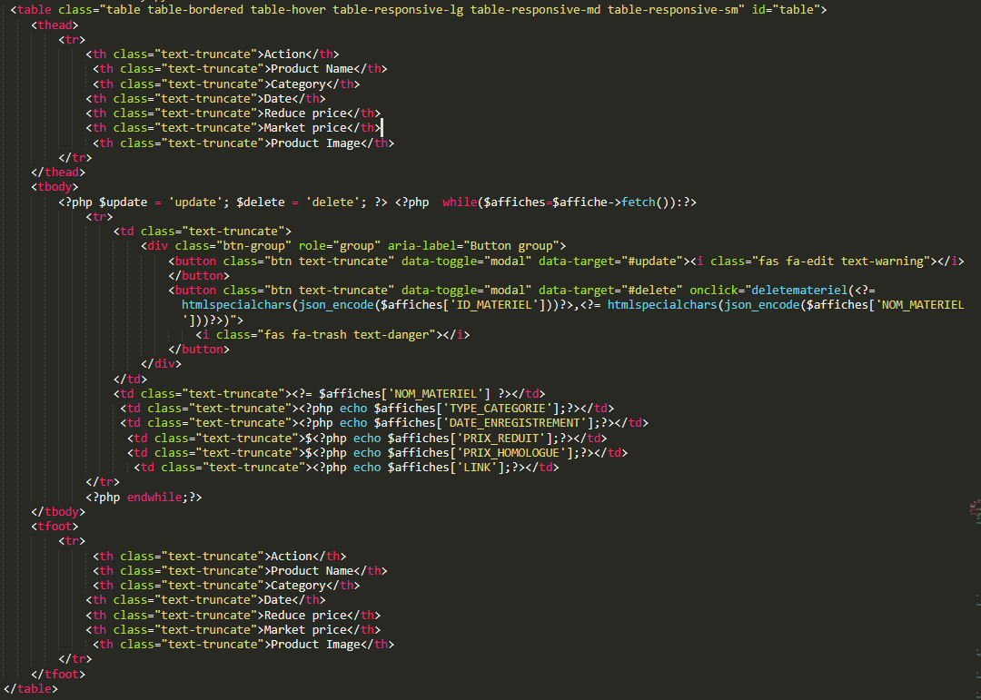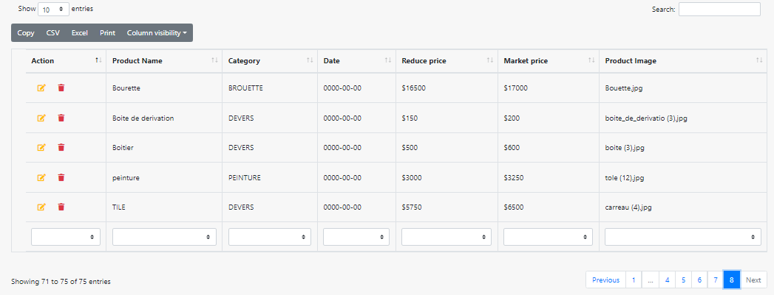

Figure 13 : Product management interface

## **Security and extension Strategy**

### **Security strategy**

For more security, each user excluding visitors is required to provide a password and a username before accessing their account. When connecting, an internal process is effectuated (authentication and retrieval of his right in the database) which gives him the possibility of accessing our application according to his right. A user who connects to our application can only perform actions related to his right. In addition, we have provided all of our inputs with scripts to increase security and we require our users to provide their CNIB number when creating their account.

### **Extension strategy**

Our application is designed for hardware stores and mini hardware stores in Burkina Faso that do not have an e-commerce solution and their customers. As an extension strategy :

* We offer them a possibility to use our app for a period of 6 months with free support and training.
* Each manager or responsible of a hardware or mini-hardware store can have a hardware or mini-hardware account at affordable cost and took care of its management within our application.
* Our application is responsive and secure with simple and easy interfaces to handle. Indeed, whether it is a smartphone or a computer, a user is able to perform all the actions predefined by our application.
* Customers have their choice of visiting or shopping for the products at the hardware store of their choice within the platform. They can search for hardware according to cities and search for materials according to product categories. The hardware store search can be done after validating the customer's login information while the product search is done when the customer chooses a hardware store to visit or make a purchase.

We intend to popularize our application through its advertising on social networks (Facebook, LinkedIn and Instagram).

In addition, we will organize awareness campaigns every year for our target audience on the advantages of using e-commerce tools including our application for the sale and promotion of their services. Through the free trial and assistance strategy we will be able to return to have potential customers who will advertise us from now on.

Also the digital week which is held each year in Burkina Faso with a view to promoting and popularizing digital technology can serve as an event to better popularize our solution.

This chapter has enabled us on the one hand to present the results of our research and some codes and interfaces of our application. On the other hand, it allowed us to broach our security and popularization strategy. The following will be the conclusion and perspective part which closes our discussion.

# **Conclusion and perspective**

Our theme project "hardware stores products online selling web application development " consists of implementing a web solution for the sale of hardware products intended for hardware stores and mini hardware stores in Burkina Faso.

In order to carry out our project well, we have structured our work as follows. First, we took care of our target audience to better understand their reality and collect their needs in order to design a solution that takes into account their needs and realities. Then we specified the functional and technical needs. Finally, we moved on to its development. For the realization of the said solution software such as wampserver 3.2.3, sublime 3.2.2, power MC, StartUML and programming languages ​​like PHP7.3.21, HTML5 / CSS and AJAX, MYSQL 8.0.21 were very useful to us. In addition, the UML language was also used for the modeling of our solution.

The objective of the project is to make Burkina Faso's hardware and mini hardware store more visible and to facilitate the sale and accessibility of their products to their customers. He allowed us to highlight the knowledge acquired during the 3 years at BIT. Also through it we became more familiar with the tools and software used in web development.

Most of the features defined in the functional requirements specification section in part II to chapter 1 have been developed and tested. For this, we ask hardware and mini hardware stores to kindly use our solution since it is well suited to their needs and offers them a lot of advantage (gives expected result part I to chapter 1 and popularization strategy part II to chapter 2). Our application can be developed using sessions, cookies and other algorithms to better manage users, that is to say to trace the actions and tasks performed during a given period. Through this same strategy we will be able to optimize the sale of hardware stores and mini hardware stores in Burkina Faso and improve the security of our application.

# **Bibliography and bewbography**

**Bibliography**

* Laurent AUIBERT [04-15-2021 UML2.0], (IUT, IT department, 1st year)
* UML 2 ANALYSIS AND DESIGN Algeria-Educ.com

**Memory**

Etienne BELEMGNEGRE theme << Restaurant management system >>

**Webography**

* [1][https://www.netoffensive.blog/e-commerce/statistiques/#:~:text=D'ici%202040%2C%20les%20%C3%A9tudes,d'au Augment%20tous%20les%20ans](https://www.netoffensive.blog/e-commerce/statistiques/#:~:text=D'ici%202040%2C%20les%20%C3%A9tudes,d'augmenter%20tous%20les%20ans). Visited [2021/26/05]
* [2]<https://www.scribbr.fr/methodologie/resultats-de-recherche-academique/>. visited [07/01/2021]
* [3][https://www.scribbr.fr/memoire/example-de-resume-dun-memoire/](https://www.scribbr.fr/memoire/exemple-de-resume-dun-memoire/). visited [2021/10/06]
* [4][https://www.pinterest.com/pin/838725130589766077/?amp_client_id=amp-uf5l8pDoczkTt-2k2TcGow&mweb_unauth_id=44b72760407a4b3b80b23fb0294b83bd&_url%8pDoczkTt-2k2TcGow&mweb_unauth_id=44b72760407a4b3b80b23fb0294b83bd&_url%9FieczkTt-2k2TcGow&mweb_unauth_id=44b72760407a4b3b80b23fb0294b83bd&_url%9Fiec2%2Ainterest%3wind %3%2Fiec2Attest%4Atween%2Fiec2Attest%3Andweet%4Fiec2%2Attention% -powerpoint-defense% 2F](https://www.pinterest.com/pin/838725130589766077/?amp_client_id=amp-uf5l8pDoczkTt-2k2TcGow&mweb_unauth_id=44b72760407a4b3b80b23fb0294b83bd&amp_url=https%3A%2F%2Fwww.pinterest.com%2Famp%2F4geniecivilcom%2Fexemple-de-pr%25C3%25A9sentation-powerpoint-soutenance%2F) visited [2021/24/06]

# **Summary of appendices**

# **APPENDICES**

Appendix 1: Survey form …………………………………………………………………... ..35

**Appendix 1: Survey form**

Inquiry Form

We are students of Burkina Institute of Technology (bit.bf) at the end of the cycle.

We are working on a project related to sales, visibility and advertising

hardware products and we ask you to answer some questionnaire

1. Do you have communication channels for the sale of your products?

Yes

No

If yes, which ones ?

: ------------------------------------------------- ----------------------------------------

1. Through these channels are you gaining more customers?

Yes

No

Not really 

1. Have you thought about other communication channels?

Yes

No

If yes, which ones ?

: ------------------------------------------------- -----------------------------------------

1. Do you know the web applications?

Yes

No

A little 

1. Do you think web applications are important?

They are important

No idée

They are a little imported 

1. What are the existing solutions in relation to your needs?

Adaptées

No idée idée

Inappropriateées 

1. What is the state of the cost of acquiring existing solutions?

Very expensive

No idée idée

Inappropriateées 

1. Do you need a solution to make it easier to sell and advertise your services or products?

Yes

No

Thank you for the time devoted to receiving and responding to questionnaires

We have chosen to present the responses of 5 hardware and mini hardware managers